How to build water ports

Things needed:

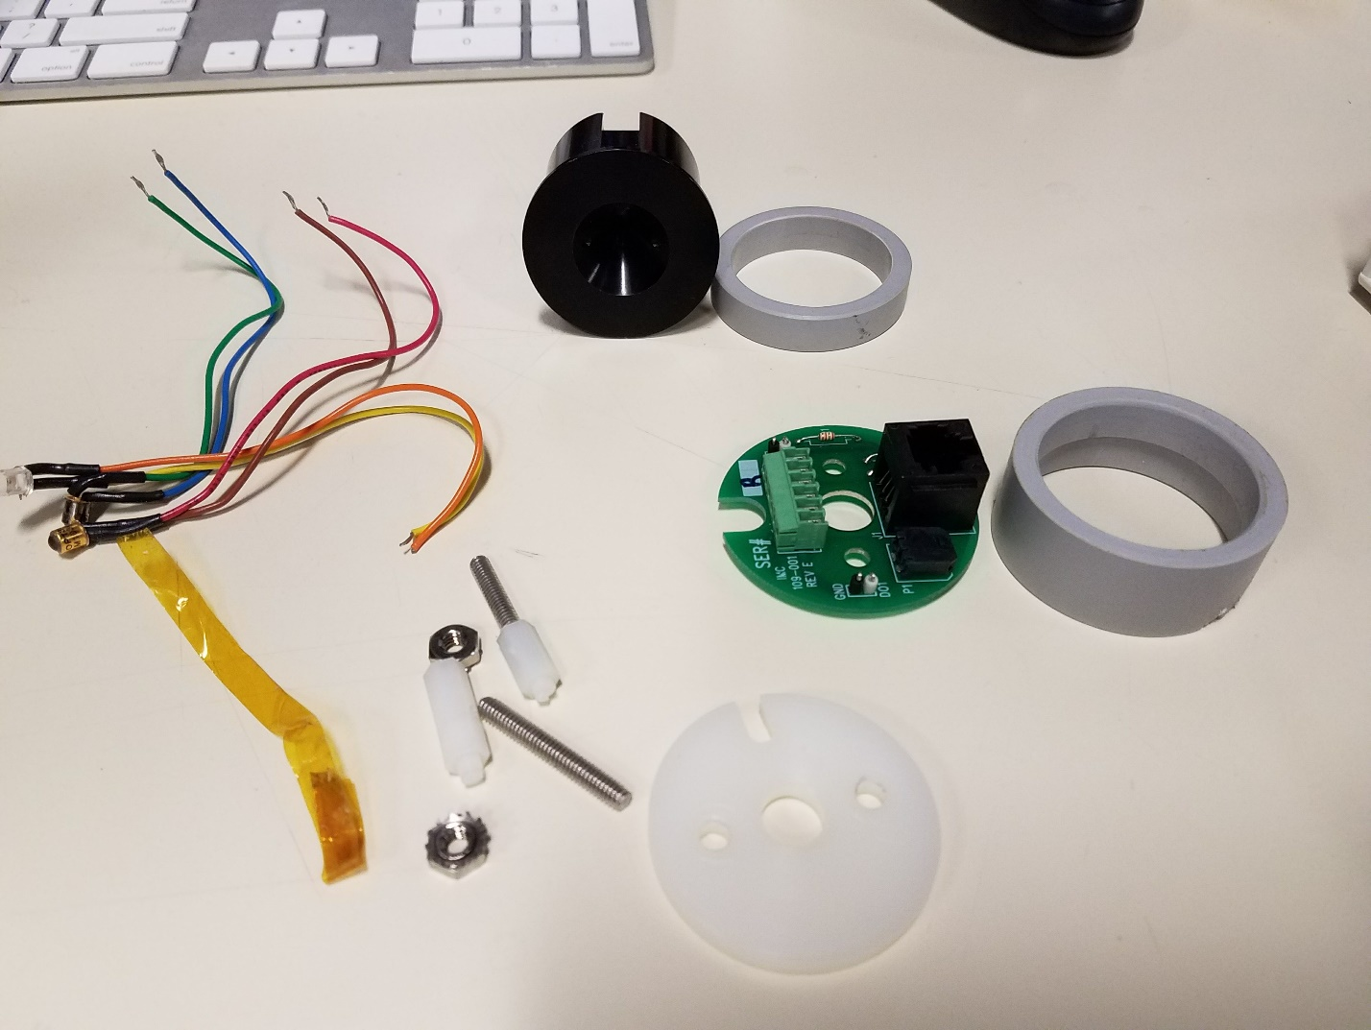



These are the parts necessary to make a water port. The machined plastic parts and board can be made by contacting Rob from the machine shop in Dolan Hall; he will provide all necessary items shown.

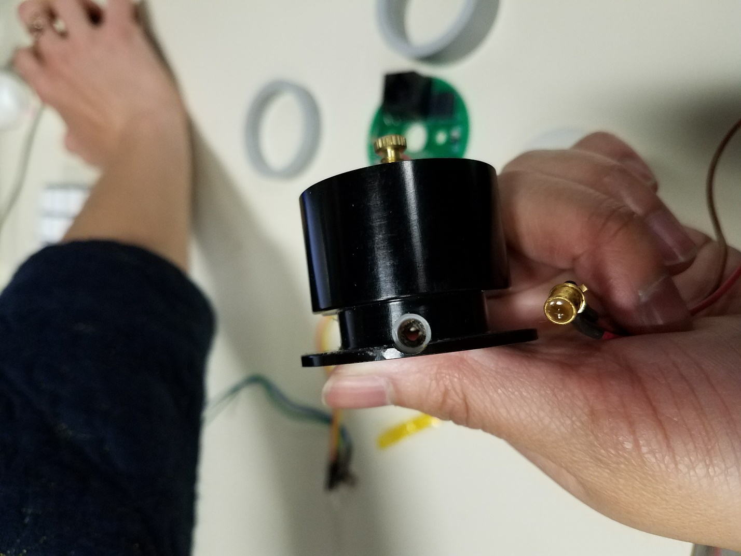



At the top of the port, there are holes to place the infared sensors and LED. Holding the lick spout side away from you, connect the brown and red wire to the left (Infared sensor); the orange yellow wire to the center (LED), and the green blue wire to the right (infared sensor). See below:

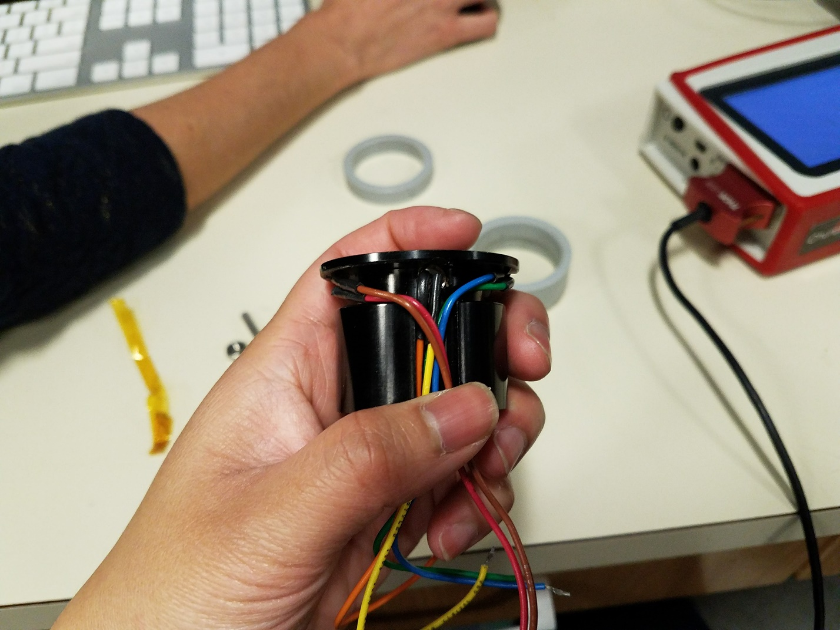



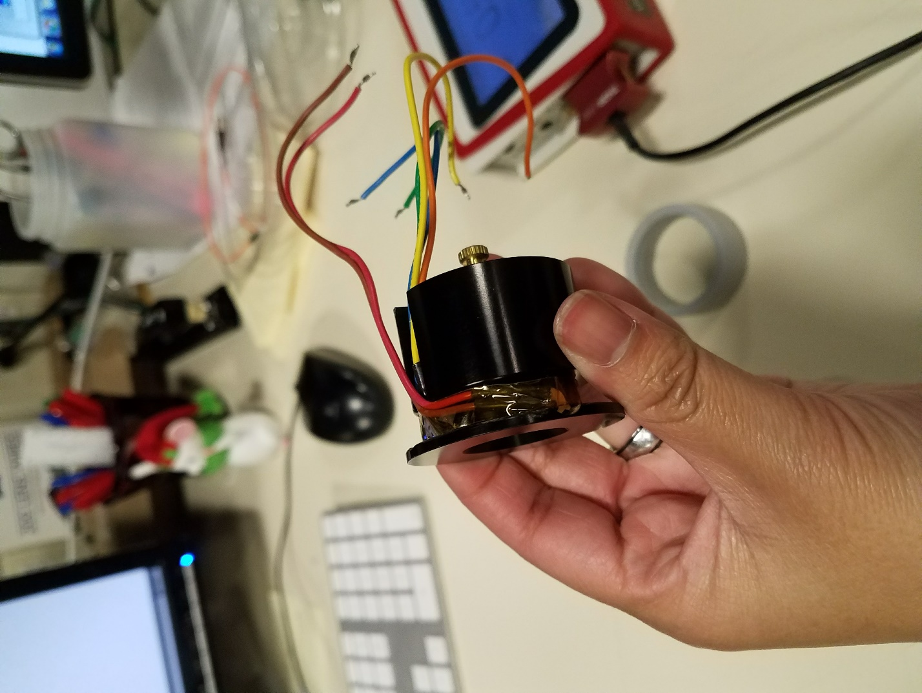

You can then use tape or rubber bands to keep the wires in place.

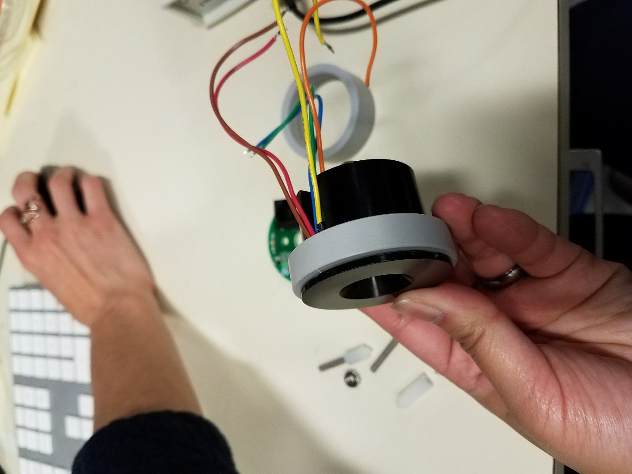



Then put the smaller plastic ring around to sheild where the wires are.

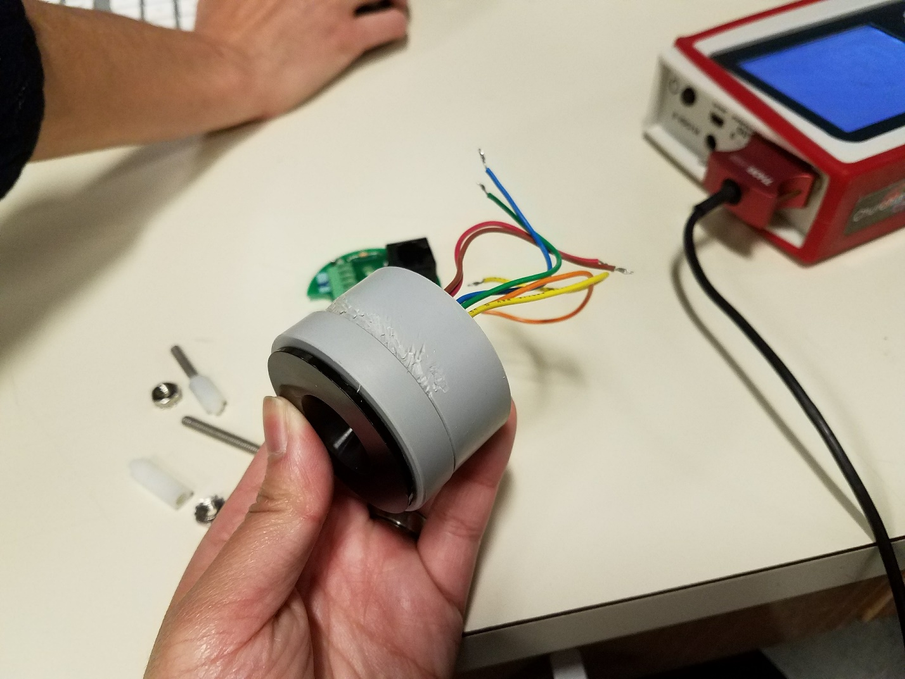



Then the bigger ring goes around the port. (This one is a bit chewed up from prior use, don’t be surprised if yours doesn’t look like this :p ) This part should then be placed on the inside of the rig.

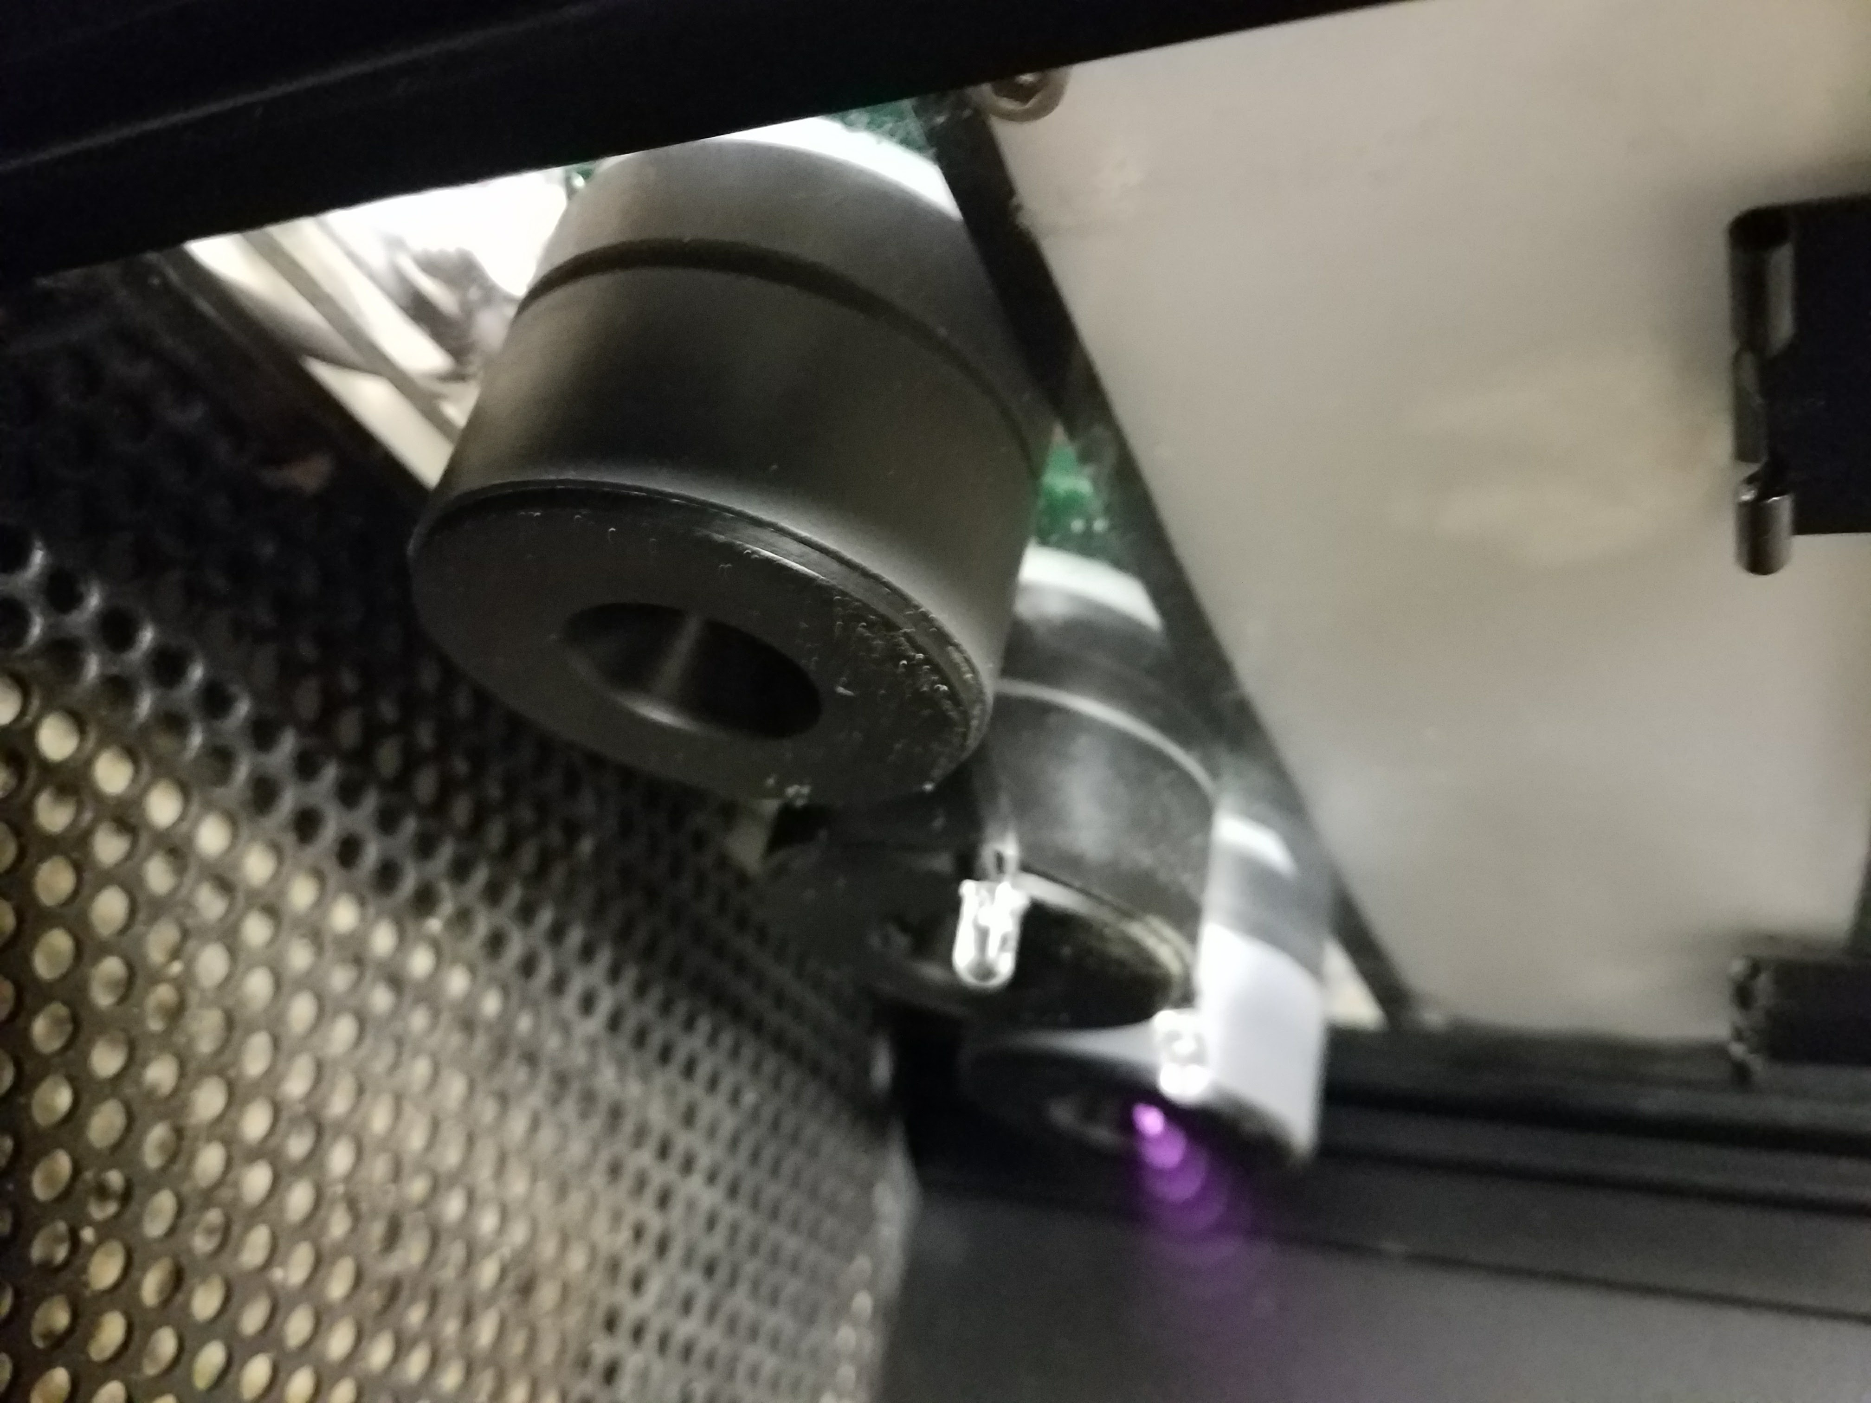

We will now assemble the port at the back part of the rig.

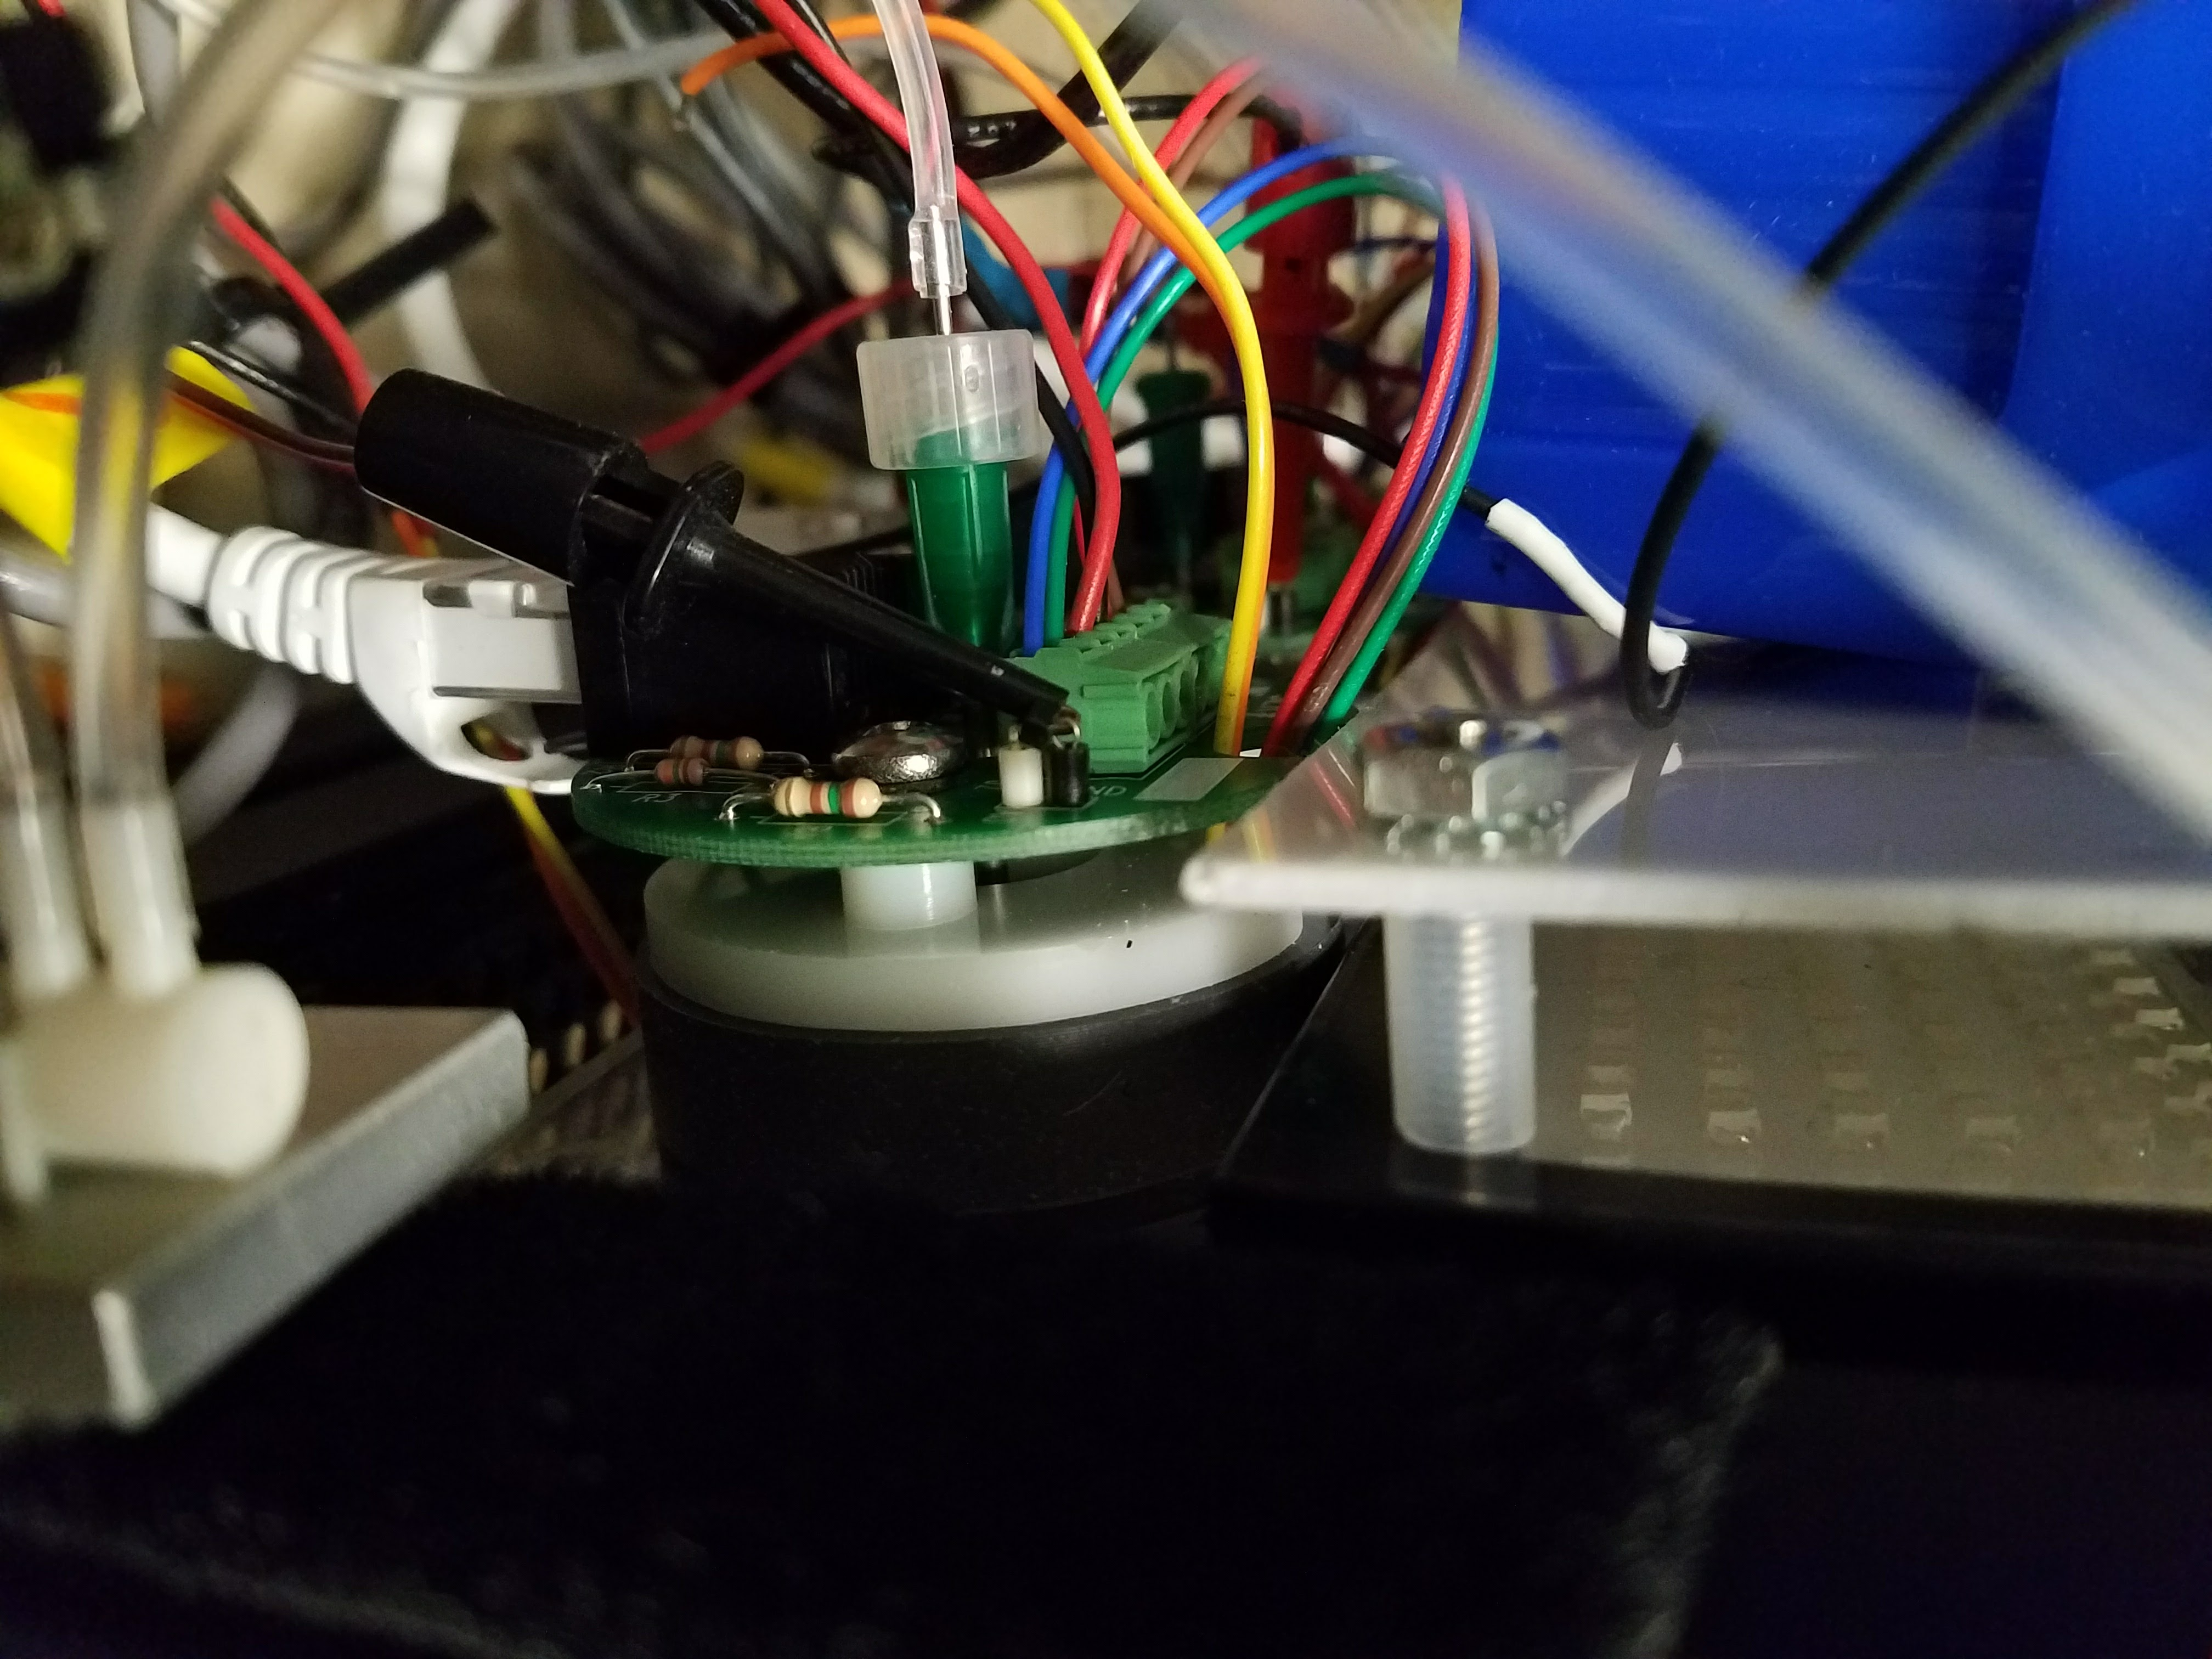

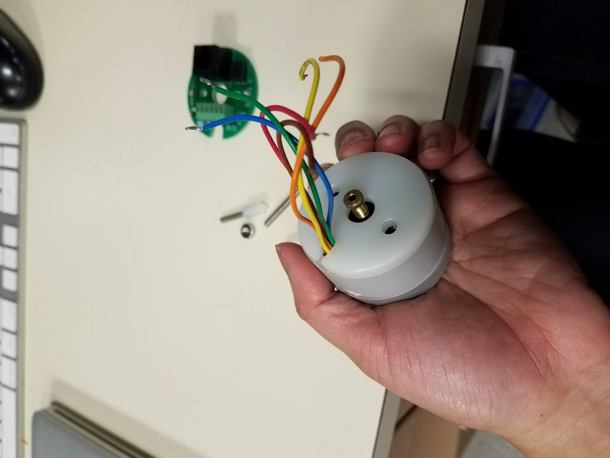 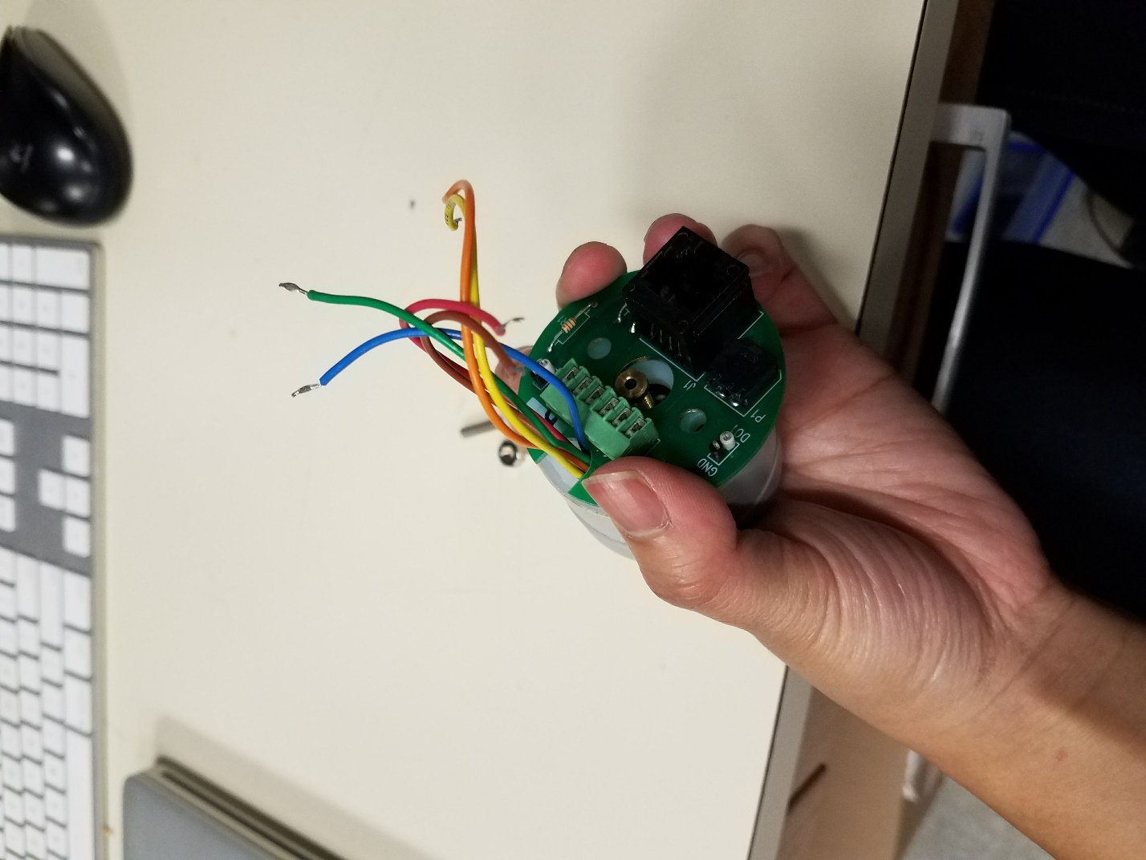



Tighten the screw inside of the center of the port. (This holds the syringe in place so make sure it’s in snugly.) Then placed the white piece and then the green board over the green, aligning the holes for the screws. See below:

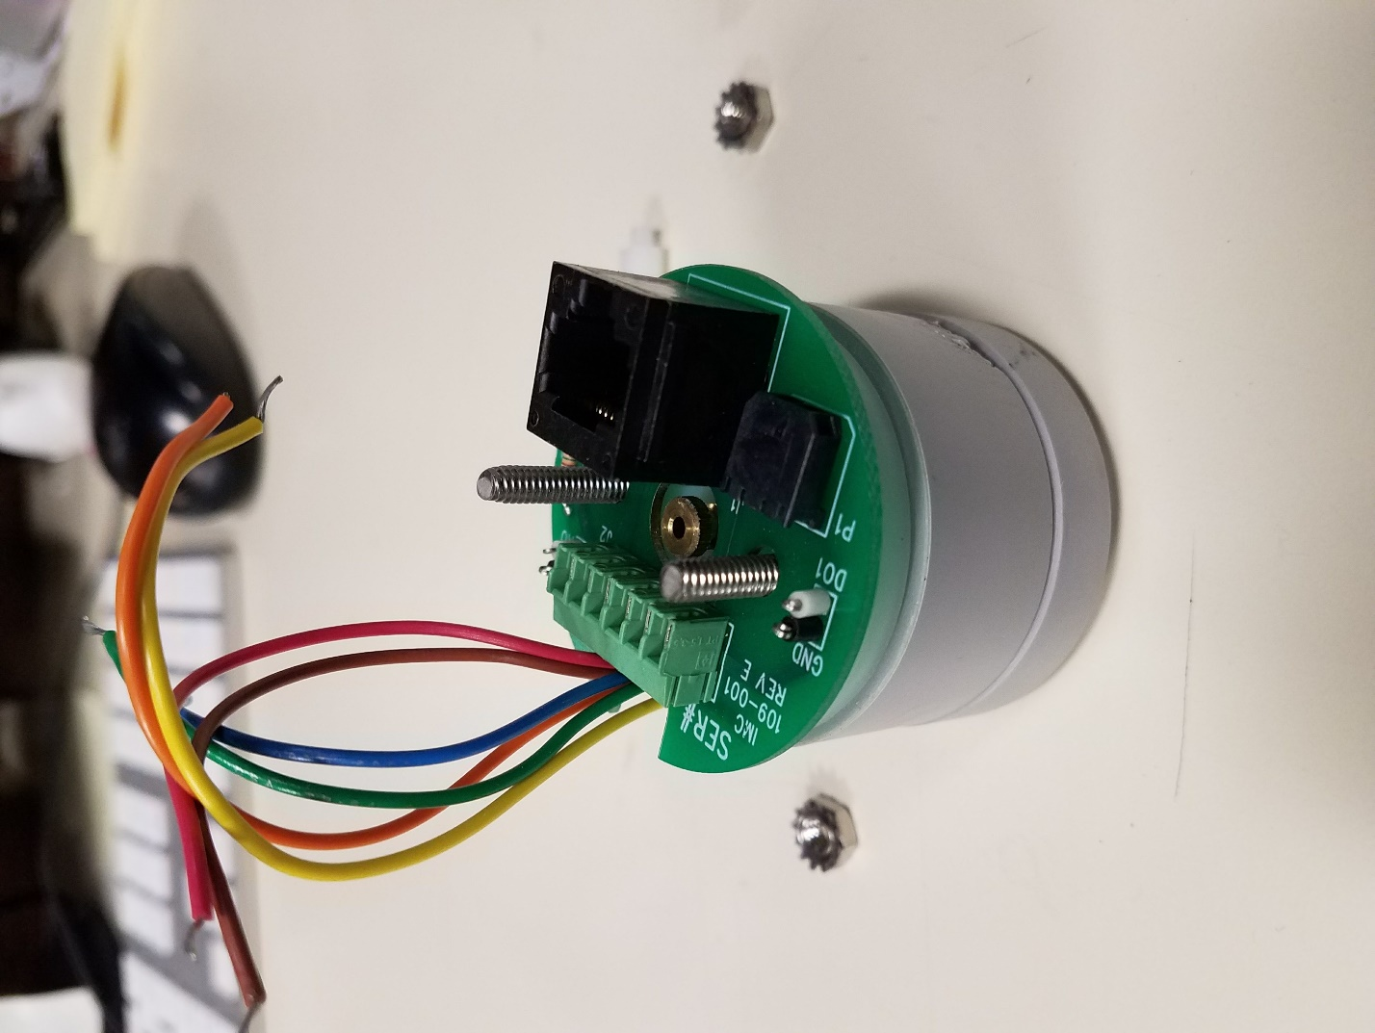



Use the nuts to tighten the screws around the white piece and the green board. And then you can add the spacers.   
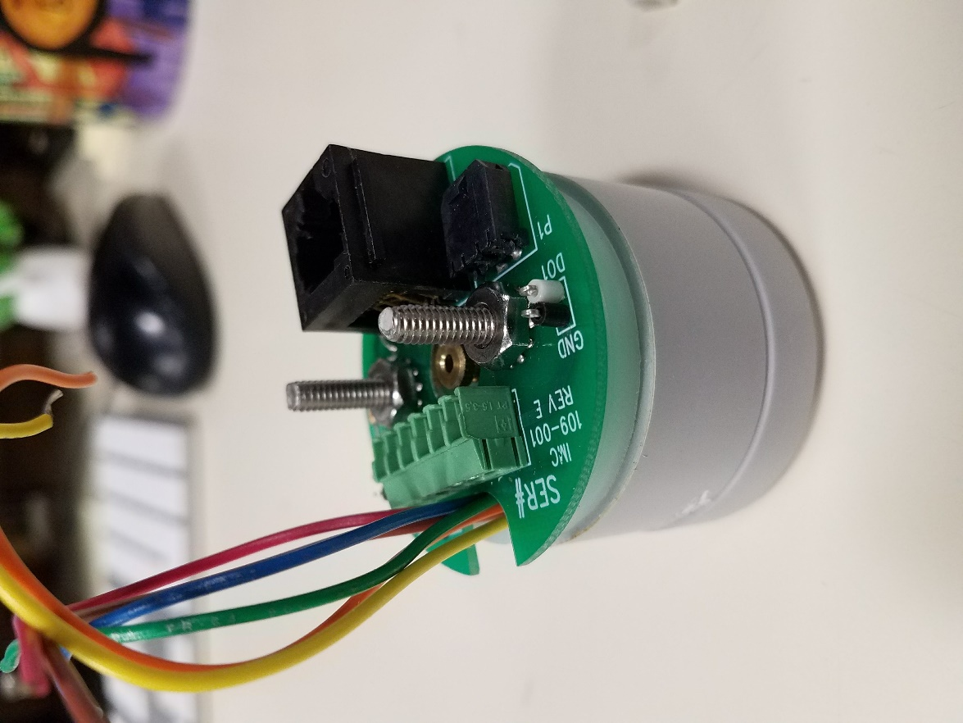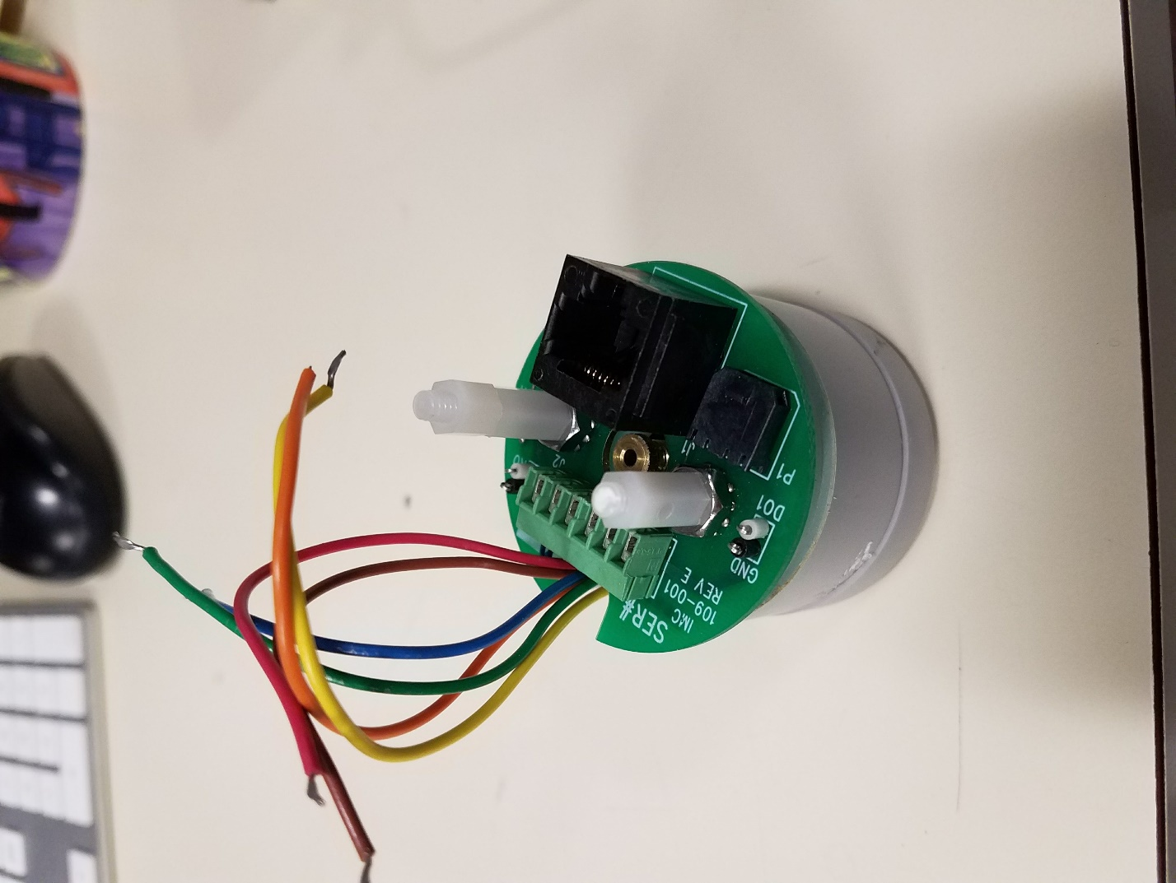



Next up is connecting the wiring. These are the wires for the LED and infared sensor. They need to be connected to the green board. The two important areas are shown below:

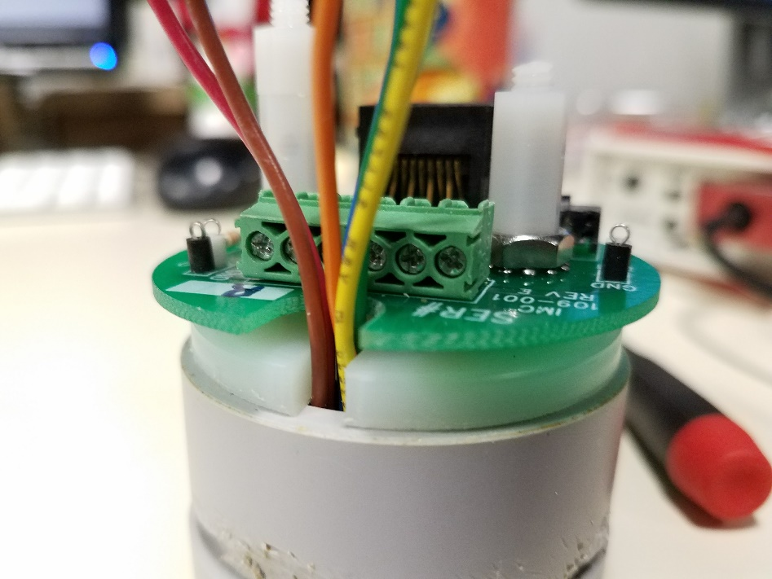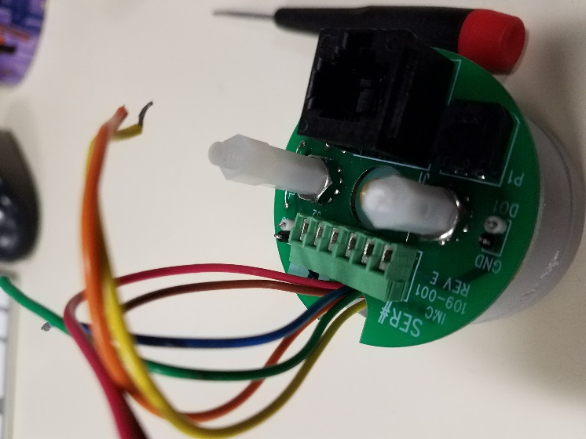



The wires need to be placed into the contacts and then screwed in at the top.

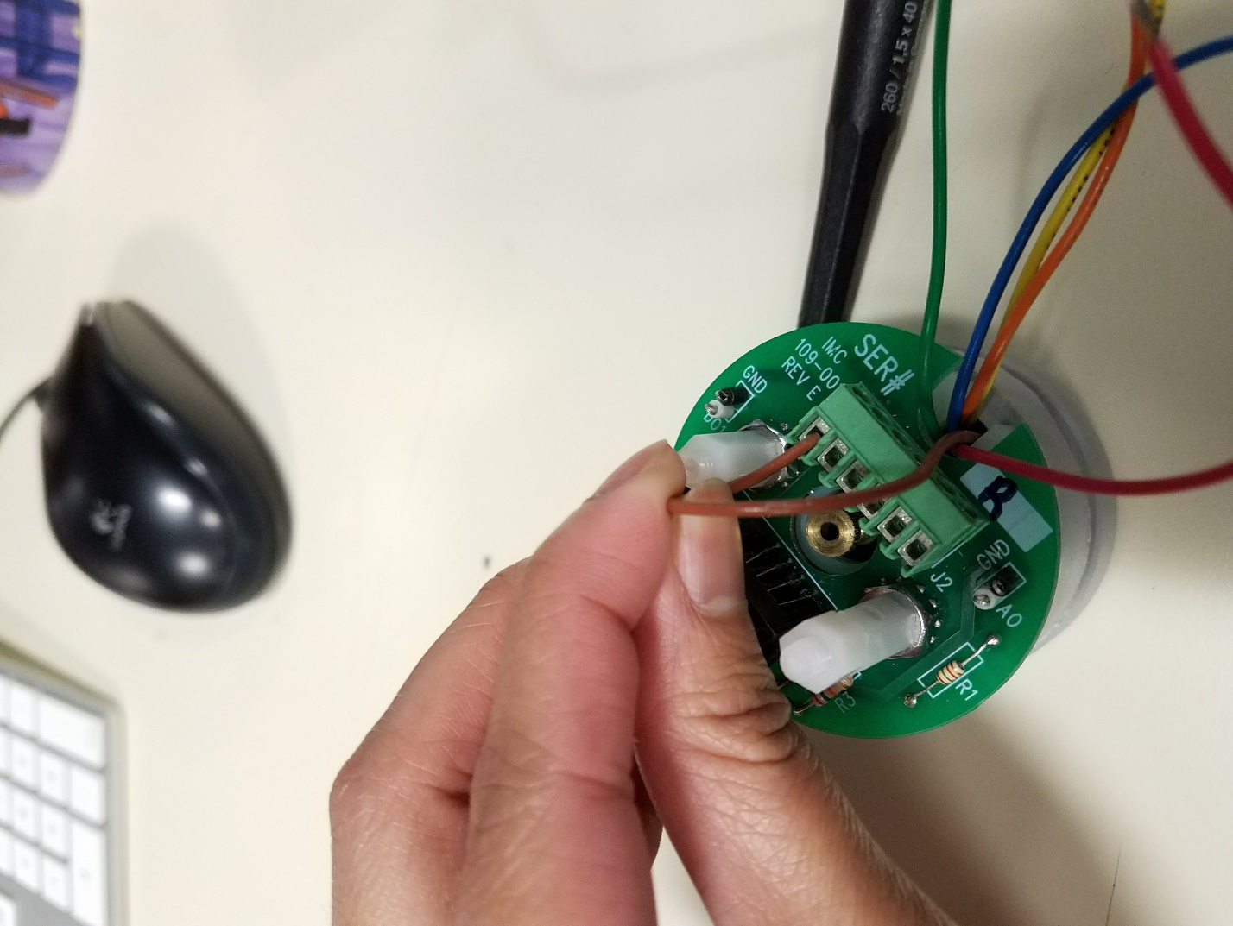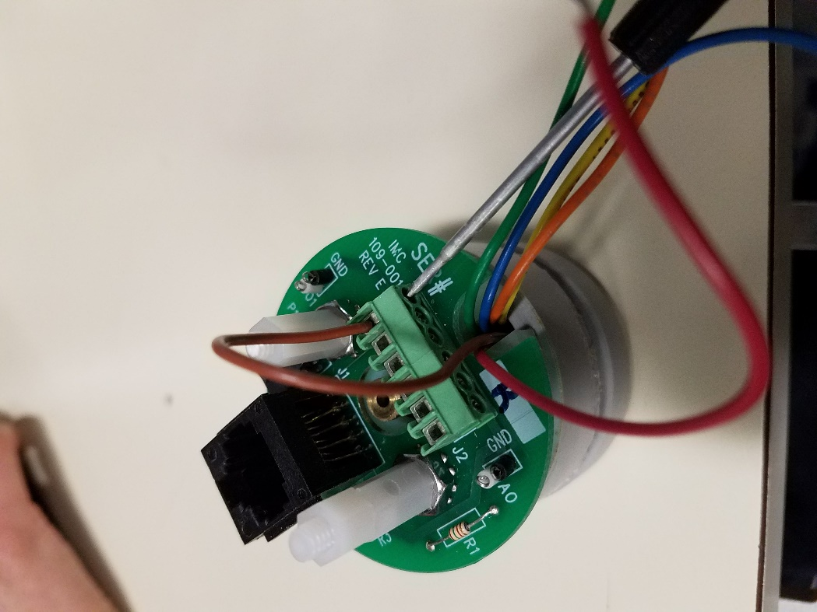



The color order should be Brown, Red, Orange, Yellow, Green, Blue. Think of “brown and then ROYGB[IV]”

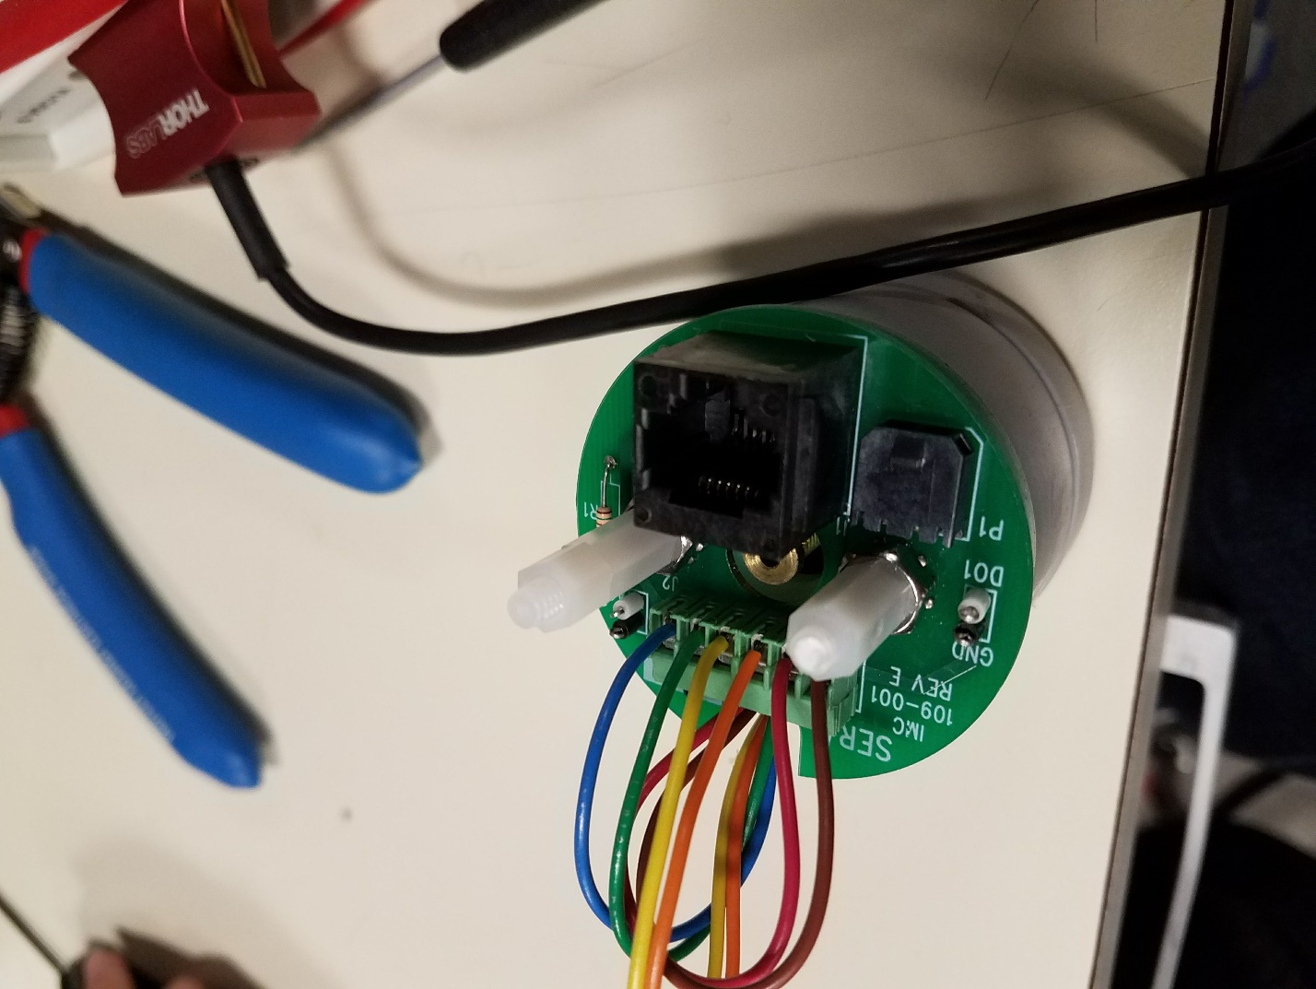

And you’re all done! Connect the solenoid and the ethernet port and you’re ready to go!

